WBSA EASE VFO LSR LQ Region (Western States) Pre-Ordering and Ordering Job Aid

Contents
EASE LSR Login 2
LSR Preorder 3
Preorder – A=Address Validation 5
Preorder – B=Telephone Number Inquiry 7
LSR New Install PON 9
Preorder – D=Appointment Scheduling 19
Submitting the Order 21
EASE LSR Logout 23

DISCLAIMER: It is the customer’s responsibility to ensure they are using the most updated document. LUMEN is not responsible for updating or notifying the customer of industry change. Lumen updates to the document will be posted in the Wholesale Broadband product catalog at https://www.centurylink.com/wholesale/pcat/wbsaresale.html.

EASE LSR Login
Follow the steps below to login to EASE VFO LSR.
Step | Action
1 | To access EASE VFO, copy/paste or ctrl click https://ease-lsr.centurylink.com/ . (Note: Use Chrome for browser)  - User Name: Enter User Name  - Password: Enter Password  - Module: select Local from the dropdown  - Click Login  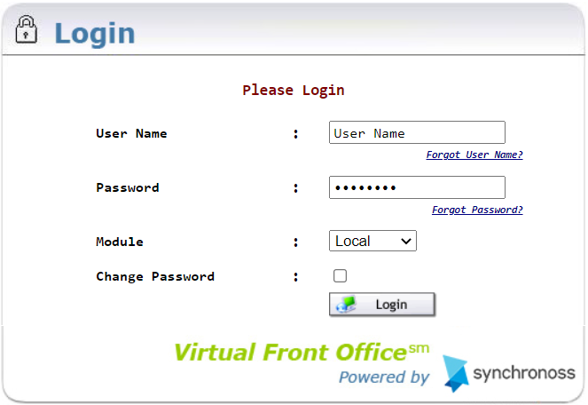  Result: Home Page/Status Screen Displays.  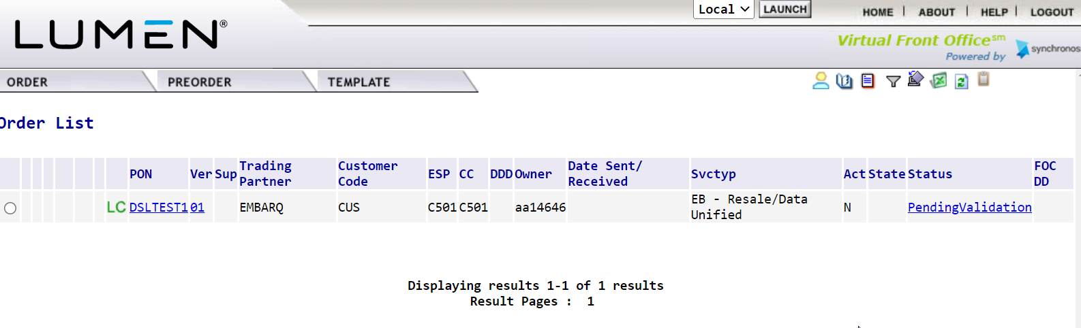

LSR Preorder
Preorder is an option that provides address validation and speed qualification, telephone number reservation, and due date and appointment scheduling. The information can be saved and retrieved later into an LSR. Follow the steps below to initiate a Preorder.
- 3 preorders will be required: 2 before beginning the order, 1 before submitting the order
- Entries should be made in ALL CAPS.

Step | Action
1 | Hover over PREORDER and click New.  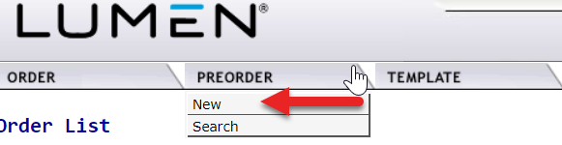
2 | - Enter the Managed ESP in Managed ESP field, if necessary. It will be the ESP that includes access to the Qwest region RSID.  - Enter a Tracking ID in the TXNUM Field (Note: This will be used to search for any saved Preorder queries)  ALERT! Please make note of the TXNUM populated as it will be used to retrieve preorder information on later steps. The same TXNUM may be used on all three preorders.

LSR Preorder (Continued)
Step | Action
3 | - Select the OCN in OCN field.  - Select a Preorder option from the TX Type field.  Utilize Values of:  A=Address Validation  B=Telephone number Inquiry  D=Appointment Scheduling  E=Customer Service Information  H=Loop Qualification  - Click Initiate  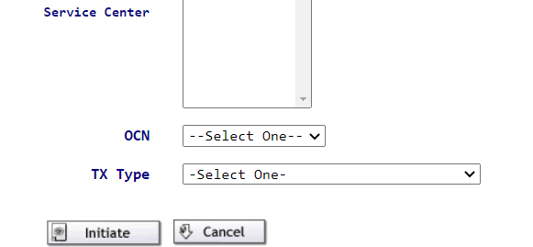
4 | Depending on the TX Type selection, please go to that Step/Action section of this guide.  Note: Three preorders will be required for orders placed in the LQ Region: Address Validation, Telephone Number Inquiry, and Appointment Scheduling.

Preorder – A=Address Validation
After selecting Address Validation from Pre-order options, the Address Validation screen will appear. It allows for validation of Street Address or Telephone Number and returns the available DSL technologies and speeds.

Step | Action
1 | Enter the following fields as required:  - CCNA – Qwest region RSID/Company Code  - STATE – Two Alpha characters  - Within the SVC-ADDR-GRP:  - SANO – Svc Address Number (required)  - SASD – Svc Address St Direction Prefix (required if part of address)  - SASN – Svc Address Street Name (required)  - SATH – Svc Address Street Type (required)  - SASS – Svc Address St Dir Suffix (required if part of address)  - CITY – Required  - STATE – Two Alpha characters (required)  - ZIP (required)  - LD/LV – Supplemental information such as unit, bldg., etc. (required if part of address)  - Click Submit  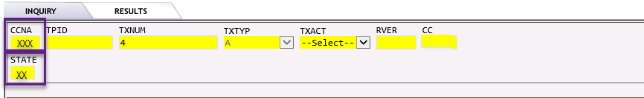

Preorder – A=Address Validation (Continued)
Step | Action
2 | Example of Exact Address Match Found. NOTE: use scroll bar for down and up and left and right  - If Exact Address Match Found, click Save and make note of the LSO and SITEID  Or  - If Near Match returned:  - Review the alternatives.  - Click on Change  - Return to step 1.  NOTE: Speeds may be higher if grooming is authorized during order submission. The conditional qualification message will append the value COND to the associated technology. To use the higher conditional speed, the LSR Form SCA field must be Y for submission.

Preorder – B=Telephone Number Inquiry
After selecting Telephone Number Inquiry from Pre-order options, the Telephone Number Inquiry screen will appear. It allows reserving a telephone number to be used on the order.
Step | Action
1 | Enter the following required fields:  - CCNA - Qwest region RSID/Company Code  - TXACT – populate with value of A  - STATE – Two Alpha characters  - TOS – Type of Service (1BF for Bus, 2BF for Res)  - QR – enter value of available Telephone Numbers to return.  - QR=1 for most orders  - QR=2 for Bonded technology  - TNTYP – Select value of N  - LSO – Local Serving Office preferred NPA/NXX from Address Preorder  - SVC_ADDR_GRP section – enter valid service address information received from Address Validation Preorder  - SITEID – Eight Alpha characters from Address Preorder  - Click Submit

Preorder – B=Telephone Number Inquiry (continued)
Step | Action
2 | If successful query displays, proceed to next step. The saved information can be referenced by the TXNUM of the inquiry in later steps.  Or  If preorder information is incorrect, click Change to correct the information, and return to step 1.  Or  To cancel request and return to the Preorder screen, click Close. NOTE: end of this process, return to step 1.  Additionally  To obtain printable version of successful preorder, click on Printable Version.  Note: If the error below is received, contact the LQ Region LSR Order Support for assistance.  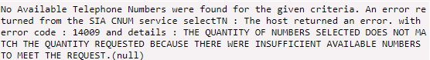
3 | Select the TN(s) to be used by clicking on the check box to the left of the TNRES field.  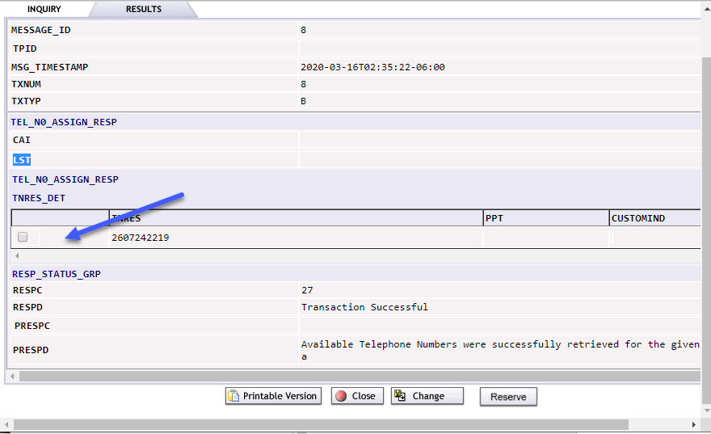
4 | Click Reserve.  A “Transaction Successful” message is received.
5 | Click Save.
6 | Click Close to exit from completed preorder.

LSR New Install PON
Follow the steps below to create and submit an LSR.
Step | Action
1 | Hover over ORDER and click on New.  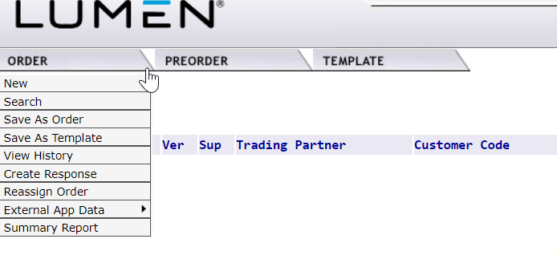
2 | - Select the Managed ESP, if necessary. It will be the ESP that includes access to Qwest region RSID.  - Enter the order number in Order Number field. NOTE: Must start with DSL. (Example: DSL12345).  - Select the OCN.  - Select EB-Resale in Service Field.  - Select N-New Installation in Activity field.  - Click Initiate.

LSR New Install PON (Continued)
Step | Action
3 | LSR Form Entry  LSR ADMIN Section:  - Enter 1 in LOCQTY field.  - Enter the Project ID in PROJECT field. It will always begin with CWS and end in BSA (example: CWSxxxxBSA)  - Select B in PROJINDR.  - Select C in RTR.  - Enter CCNA - Qwest region RSID/Company Code

LSR New Install PON (Continued)
Step | Action
3 cont. | LSR Form Entry (continued)  AUTHORIZATION section:  - Enter 1BF (for Business) or 2BF (for Residential) in TOS field.  - Do not enter the DDD. This will be populated in a proceeding step.  AUTH INFO RGP section:  - Populate AGUATH=Y (indicates permission has been obtained to place the order on the end user’s behalf)  - Populate LSP AUTH DATE with date the authorization was received.  - If ordering a speed marked COND on preorder, select Y in the SCA field. Otherwise, leave SCA blank.  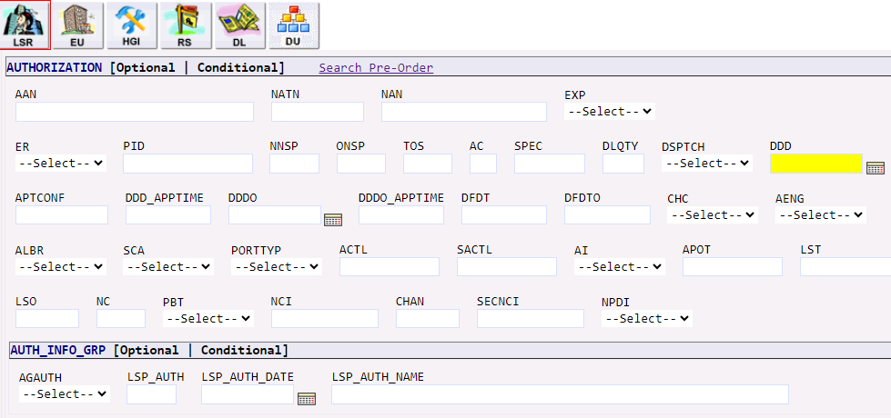  CONTACT section:  - Enter name of person creating LSR in IMPCON field (to the right of the screen)  - Enter TN of person creating the LSR in IMPCON TEL NO field.
LSR New Install PON (Continued)
Step | Action
3 cont. | LSR Form Entry (continued)  REMARKS section:  - Enter remarks pertinent to the request in REMARKS1. (Example: install pure broadband, speed 10.0)
4 | Click on EU Form  LOC ACCESS section:  - Enter 1 in LOCNUM field.  - Enter name of the end-user in NAME field, must be 2 words, ex: McDonald’s Restaurant.

LSR New Install PON (Continued)
Step | Action
4 cont. | EU Form Entry (continued)  LOC ACCESS INFO section:  - Enter local contact person in LCON.  - Enter local contact person telephone number in TEL NO.  SVC ADDR GRP section:  - Click Search Pre-Order.  - Select the saved Preorder related to this request and click on it.
LSR New Install PON (Continued)
Step | Action
4 cont. | EU Form Entry (continued)  Result: Preorder opens.  - Click PrePopulate.  Result: EU SVC ADDR GRP pre-populates with valid address.  SHIP ADDR GRP section:  Populate with service address. Although this section is required, nothing is actually shipped.  - Enter Y in SHAI field  - Enter Shipping name in SHN1  - Enter all service address fields.  NOTE: format same as address above using correlated fields.

LSR New Install PON (Continued)
Step | Action
5 | Click on RS Form  RS ADMIN section:  - Enter 0001 in RSQTY field. NOTE: enter 0002 if ordering Pair Bonded technology.  RS SVC DET section:  - NOTE: ONLY if ordering Pair Bonded technology, Click on Add to add an additional section for the 2nd TN.  - Click on Search Pre-Order  Result: Preorder opens.  - Select the saved Preorder related to this request and click the blue link.  - Click PrePopulate.  Result: TNS field populates into the LSR.
LSR New Install PON (Continued)
Step | Action
5 cont. | RS Form Entry (continued)  Note: If Pair Bonded, these sections will appear twice and must be populated. See Step 6 for additional detail.  SVC DET GRP section:  - Enter 01 in LOCNUM field.  - Enter 01 in LNUM field.  - Enter N in LNA field.  LINE RESTRICT 2 GRP:  - Enter NONE in PIC field.  - Enter NONE in LPIC field.  FEATURE GRP Section:  - Enter 5 in section(s).  - Click Add.  Result: There are now 6 Feature fields available to be populated.

LSR New Install PON (Continued)
Step | Action
5 cont. | RS Form Entry (continued)  Utilizing the WBSA External Comm Feature Code Spreadsheet, Western States Tab, enter FEATURE GRP [1] through [6] with valid USOCs for the speed/technology to be ordered.  https://www.centurylink.com/wholesale/pcat/wbsaresale.html  FEATURE GRP [1] Section:  - Enter N in FA field.  - Enter Line USOC in FEATURE field.  - If Pair Bonded, add Feature Detail information in the FEATURE DETAIL field with reference to the second reserved TN.  - Example: /BCCR 303-555-1234  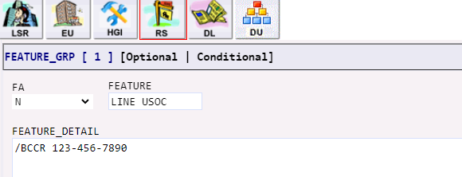  FEATURE GRP [2] Section:  - Enter N in FA field.  - Enter the Broadband Speed USOC in FEATURE Field.  - Add Feature Detail from Codes List in FEATURE_DETAIL field.  FEATURE GRP [3] Section:  - Enter N in FA field.  - Enter the ISP USOC in FEATURE Field.  FEATURE GRP [4] Section:  - Enter N in FA field.  - Enter the Modem USOC in FEATURE Field.
LSR New Install PON (Continued)
Step | Action
5 cont. | FEATURE GRP [5] Section:  - Enter N in FA field.  Enter Install USOC 1 in FEATURE Field.  FEATURE GRP [6] Section:  - Enter N in FA field.  - Enter Install USOC 2 in FEATURE Field.
6 | If Then  Not Pair Bonded - Continue to step 7.  If Pair Bonded RS_SVC_DET [ 2 ]: - Enter 01 in LOCNUM field. - Enter 02 in LNUM field. - Enter N in LNA field. - Enter NONE in PIC field. - Enter NONE in LPIC field RS FEATURE GRP Section: - Enter 1 in section(s), click Add. - Enter N in FA field. - Enter Line USOC in FEATURE Field. - Enter Feature Detail. Ex: /BCCR xxx-xxx-xxxx (1st TN) - Enter N in FA field. - Enter Broadband speed USOC in FEATURE Field. - Enter Feature Detail. Ex: /NTI FTTN-ETH-V2V-PB - Continue to Step 7.
7 | In top right corner of LSR, click on Save ICON.  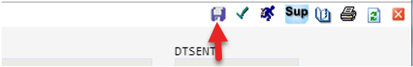
8 | In top right corner of LSR, click on Validate ICON.  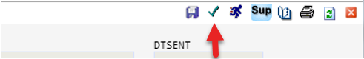
LSR New Install PON (Continued)
Step | Action
9 | If Error Code list returns, correct those errors. Errors must be corrected before PON can be submitted.  Note: Due Date (DDD) errors will remain until the final Appointment Scheduling preorder has been issued and imported to the PON. See steps below once all other errors have been cleared.  Example of Error Code List:  Note: If SC Field Required error received, populate the RSID in the SC field.
10 | Create the Appointment Scheduling preorder using the steps below.

Preorder – D=Appointment Scheduling
Utilized to reserve a due date and appointment time for the order.
Step | Action
1 | Initiate a final preorder using the same steps identified in the LSR Preorder section above. Select D = Appointment Scheduling as the TX TYPE.
2 | Enter the following required fields:  - CCNA – Qwest region RSID/Company Code  - TXACT – populate value of A  - STATE – two alpha characters  - TOS - Type of Service (1BF for Bus, 2BF for Res)  - APPRD - date 15+ days from today for expanded visibility (up to 29 days out), ex: 02-01-2024  - QR – populate value of 1 for single line technologies or 2 for pair bonded technologies.  - SVC_ADDR_GRP – populate the address fields as represented on the successful Address preorder  - PON – Purchase Order Number. Alert! This must match the PON (Order Number) used for ordering. See LSR New Install section above.  - FEAT_PP – Feature USOC code. Populate install USOC1, USOC2 and speed USOC.  Example: Ordering 10M/10M VDSL bus, enter USOCs: 1CRA3, 1CRM9, EFXPC  NOTE: To add additional USOCs, click hyperlink.  - Click Submit

Preorder – D=Appointment Scheduling (continued)
Step | Action
2 cont | 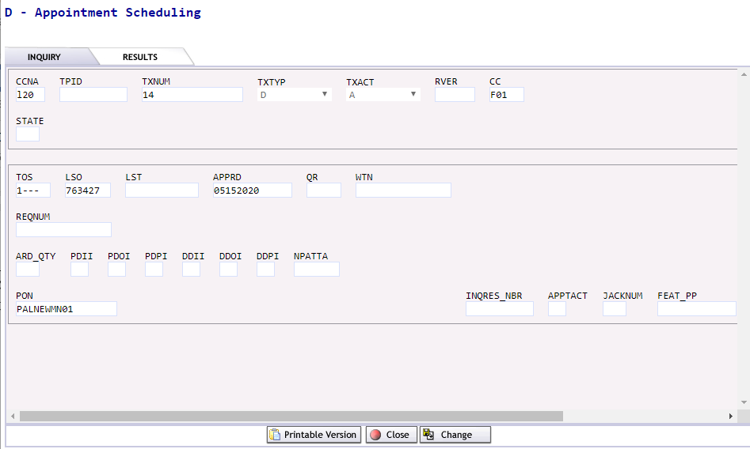  Once Preorder is submitted, the request will provide a response upon submission.  NOTE 1: If errors received, click Change to update information, or click Cancel to begin again with step 1. Additional Preorder assistance can be found in the IMA to EASE Conversion section of the CMP Site. There is a Preorder Guide in the IMA to EASE Differences document and an Appointment Scheduling video.
3 | Scroll to list of appointments.  - Click on radial button to select appointment time.  - Click Reserve  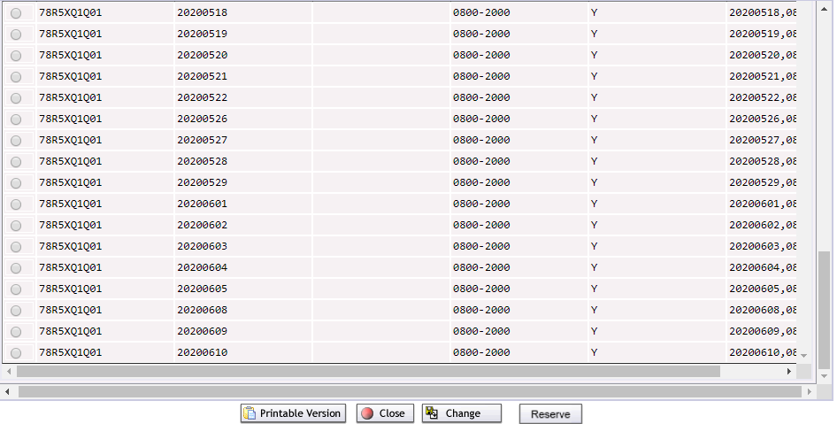
4 | Click Save.
5 | Click Close to exit from Completed preorder.

Submitting the Order
Once the Appointment preorder has been added to the PON and all errors are cleared, the order can be submitted.
Step | Action
1 | Return to the PON and access the LSR page of the order.  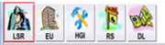
2 | In the Authorization Section, search the Appointment Preorder to pull the information in.  Authorization section:  - Click on Search Pre-Order  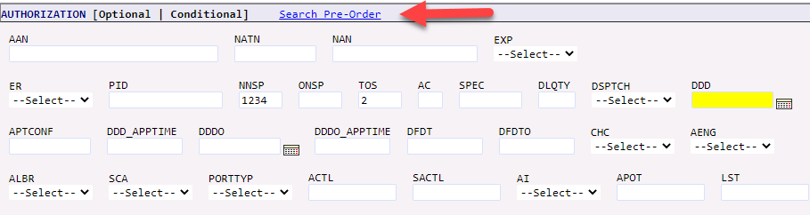  Result: PreOrder box appears.  - Select TXNUM saved earlier for Appointment Schedule for this location.  - Click Prepopulate  Result: DDD, APTCONF, DDD_APPTIME populate on to the LSR.

LSR New Install PON (Continued)
Step | Action
3 | In top right corner of LSR, click on Save ICON.
4 | In top right corner of LSR, click on Validate ICON.  - If Error Code list returns, correct those errors. Errors must be corrected before PON can be submitted.  Example of Error Code List:  - If no errors were received or once PON is error free, click on Submit ICON.  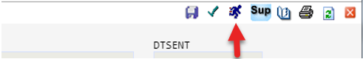  Result: STATUS will show Submitted.

LSR New Install PON (Continued)
Step | Action
5 | Click on Red X in top right hand corner to exit out of PON.  Result: Home Page/Status Screen will display.  End of process.

EASE LSR Logout
Follow the steps below to Logout of EASE VFO LSR.

Step | Action
1 | Click LOGOUT in the top right-hand corner.  Result: Login screen displays.

